Appendix 'C'
Map and Details of Secondary Schools and Education Providers

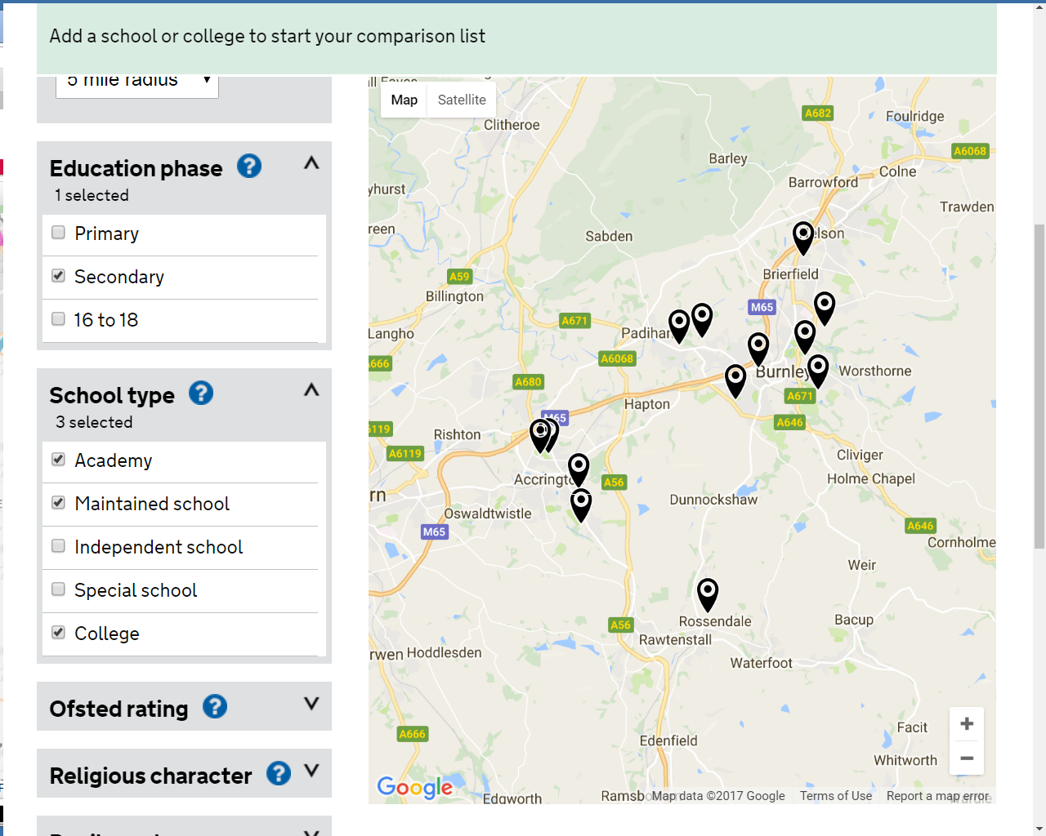
Acc' St Christophers
Acc' Academy
Acc' & Ross' College
The Hollins
Alder Grange
Shuttleworth
Burnley High School
Hameldon
UTC Lancs
Unity College
Blessed Trinity
Sir John Thursby
Marsden Heights

Hameldon Community College
Address: Coal Clough Lane, Burnley, BB11 5BT
Phase of education: Secondary
School type: Maintained School
Ofsted rating: Requires Improvement (Last inspection: 17 June 2015)
Distance: 0.04 miles

UTC Lancashire
Address: Trafalgar Street, Burnley, BB11 1RA
Phase of education: Secondary and 16 to 18
School type: Academy
Ofsted rating: No Ofsted assessment published
Distance: 0.91 miles

Burnley High School
Address: Padiham Road, Burnley, BB12 6TG
Phase of education: Secondary and 16 to 18
School type: Academy
Ofsted rating: Good (Last inspection: 23 May 2017)
Distance: 1.63 miles

Shuttleworth College
Address: Burnley Road, Burnley, BB12 8ST
Phase of education: Secondary
School type: Maintained School
Ofsted rating: Requires Improvement (Last inspection: 27 April 2016)
Distance: 1.85 miles

Unity College
Address: Townley Holmes, Burnley, BB11 3DF
Phase of education: Secondary
School type: Maintained School
Ofsted rating: Good (Last inspection: 04 June 2014)
Distance: 1.88 miles

Blessed Trinity RC College
Address: Ormerod Road, Burnley, BB10 3AA
Phase of education: Secondary
School type: Maintained School
Ofsted rating: Good (Last inspection: 12 June 2014)
Distance: 1.88 miles

Sir John Thursby Community College
Address: Eastern Avenue, Burnley, BB10 2AT
Phase of education: Secondary
School type: Maintained School
Ofsted rating: Good (Last inspection: 15 June 2016)
Distance: 2.64 miles

Marsden Heights Community College
Address: Edge End Lane, Nelson, BB9 0PR
Phase of education: Secondary
School type: Maintained School
Ofsted rating: Inadequate (Last inspection: 06 December 2016)
Distance: 3.65 miles

Accrington and Rossendale College
Address: Sandy Lane, Accrington, BB5 2AW
Phase of education: Secondary and 16 to 18
School type: College
Ofsted rating: Requires Improvement (Last inspection: 10 May 2016)
Distance: 4.15 miles

Accrington Academy
Address: Queens Road West, Accrington, BB5 4FF
Phase of education: Secondary and 16 to 18
School type: Academy Sponsor Led Mainstream
Academy sponsor: United Learning
Ofsted rating: Good (Last Inspection: 11 March 2015)
Distance: 4.48 miles

The Hollins Technology College
Address: Hollins Lane, Accrington, BB5 2QY
Phase of education: Secondary
School type: Maintained School
Ofsted rating: Good (Last inspection: 09 October 2013)
Distance: 4.53 miles

Accrington St Christopher's Church of England High School
Address: Queen's Road West, Accrington, BB5 4AY
Phase of education: Secondary and 16 to 18
School type: Academy
Ofsted rating: Good (last inspection: 06 December 2016)
Distance: 4.66 miles

Alder Grange School
Address: Calder Road, Rossendale, BB4 8HW
Phase of education: Secondary and 16 to 18
School type: Maintained School
Ofsted rating: Good (Last inspection: 02 May 2013)
Distance: 4.91 miles

